Walkthrough: Devel HTB Machine
This report outlines the penetration testing process for "Devel," a beginner-level Windows machine. The goal was to gain administrative access and retrieve the root flag. The machine's relative simplicity highlights the security risks associated with default program configurations.
1. Initial Reconnaissance and Service Enumeration
An Nmap scan on the target IP address, 10.10.10.5, revealed two open ports:
- Port 21/tcp: Running Microsoft FTPd, allowing anonymous login.
- Port 80/tcp: Hosting a Microsoft IIS httpd 7.5 web server.

2. Gaining a Foothold - Anonymous FTP and Web Shell Upload
Anonymous FTP login was permitted, allowing access to the web server's directories. This presented an opportunity to upload a malicious file. An aspx format reverse TCP handler was created using msfvenom. This shell.aspx file was then uploaded to the FTP server using the put shell.aspx command

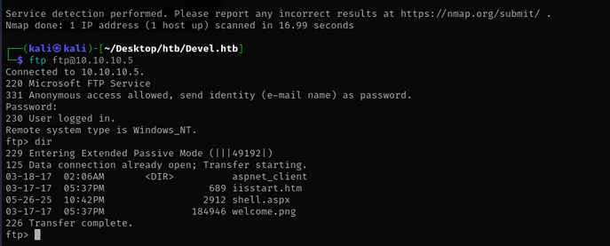
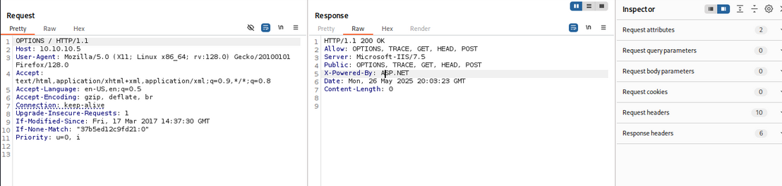

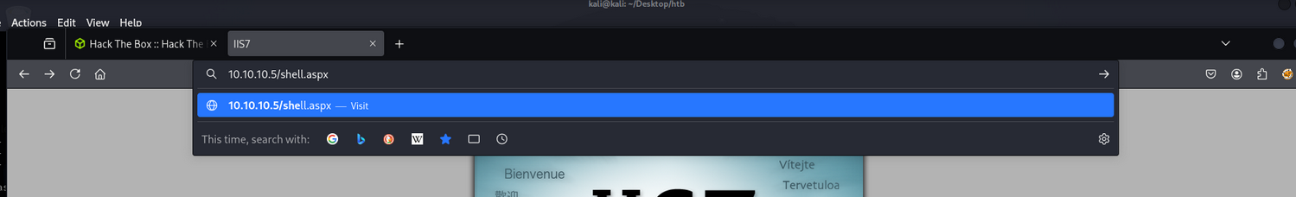

3. Establishing a Session - Metasploit Multi/Handler
After uploading the web shell, a multi/handler was set up in msfconsole with the payload windows/meterpreter/reverse_tcp. The local host and port were configured, and the handler was initiated. By navigating to http://10.10.10.5/shell.aspx in a web browser, a Meterpreter session was successfully established on the target machine

4. Privilege Escalation - Local Exploit Suggester and kitrap0d
To achieve root access and retrieve the root flag, it was necessary to upgrade the Meterpreter shell. The local_exploit_suggester module within Metasploit was used to identify potential privilege escalation vulnerabilities.
Based on the suggestions and prior experience, the kitrap0d exploit (exploit/windows/local/ms10_015_kitrap0d) was chosen for its effectiveness on IIS environments. The Meterpreter session was set, and the exploit was executed, leading to a successful privilege escalation.

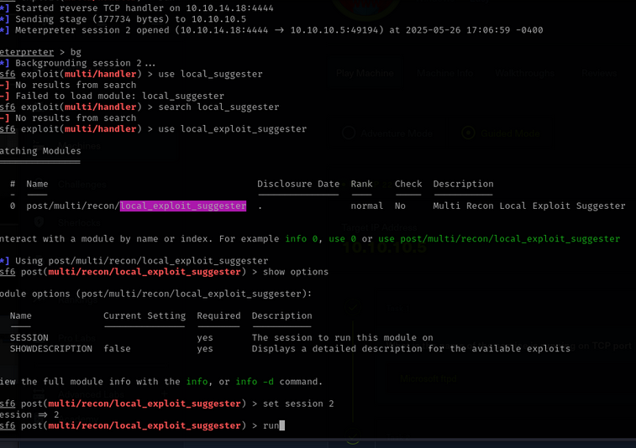
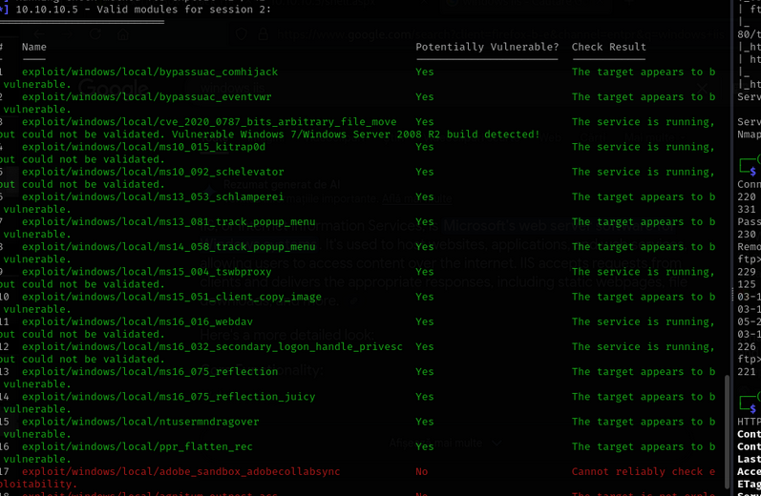
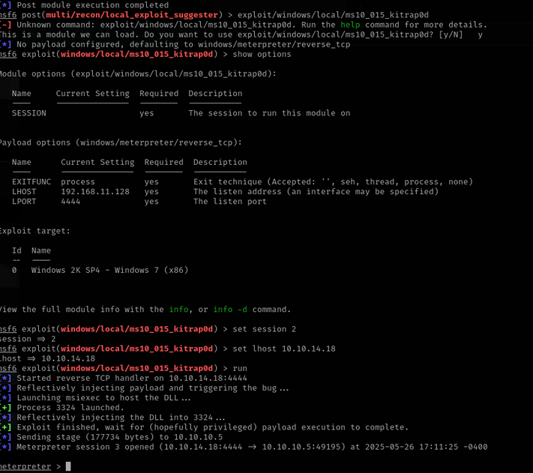

5. Flag Retrieval
With elevated privileges, the user and root flags were located at the following paths:
- User flag: C:\Users\babis\Desktop\user.txt
- Root flag: C:\Users\Administrator\Desktop\root.txt

